A
Project Report
On
My Directory Pages
Developed At
Saurashtra University
Department of Computer Science
- Rajkot
As a Partial Fulfill of MSc. IT & CA Sem-1
Academic Year 2017-2018
Submitted To
Saurashtra University
Department of Computer Science
– Rajkot

Under the Guidance Of
Prof. Shrusti Ramani
Developed By
Manthankumar Satani
Index

No. | Topic Name | Page No.
1. | Project Profile | 1
2. | Project Defination | 2
3. | Abstract | 3
4. | Preface | 5
5. | Aknowledgement | 6
6. | Notation | 7
7. | Introduction | 14
8. | System desine tool | 16
9. | Software requrment | 26
10. | Desine Document | 34
11. | DFD | 35
12. | ER Diagram | 39
13. | Data Dictionary | 42
14. | Screen Shots | 52
15. | Enhancement of project | 69
16. | Limitation of project | 70
17. | Conclusion | 71
18. | Bibliography | 72

1. Project Defination

- Project Title:-
My Directory Pages
- Frontend Tool:-
ASP. NET
- Backend Tool:-
SQL Server 2008 R2
- Project Guide :-
Prof. Shrusti Ramani
- Developed By:-
Manthankumar Satani
- Submitted to:-
Saurashtra University Department of Computer Science Rajkot
- Academic Year:-
2017-2018
- Academic Stream:-
I Semester of MSc. IT & CA (Master of Science in Information Technology and Computer Application)

Abstract

My Directory Pages providing a great platform of gathering all businesses together.

In this Project, the main purpose of the website is to provide the platform to the businesses that they can get registered on the website and get other businesses details.

In this Web-Site, main two types of users would be there.
- Administrator
- Executive

Initially the User Admin can manage their web site content with full rights.

Remain user account is “Team Leader & Executive” with limited rights. The rights related Edit and Delete are banned by the Administrator.

Candidate’s Declaration

We declare that final semester report entitled “My Directory Pages” is our work conducted under the Master guide, Pro. Shrusti Ramani.

We further declare that to the best of our knowledge the report for MScIT&CA( SEM-1) semester does not contain part of the work which has been submitted for the award of MScIT&CA( SEM-1) Degree either in this or any other university without proper citation.

Manthankumar Satani

Preface

- This website is used to register the businesses.

- This website is used to get the registered businesses details.

- User can give the feedback and contact to the administrator using contact us page.

- User can choice various categories of businesses.

- User can search the business by business name.

- This site is developed in ASP.NET at front end and uses the SQL server 2008 R2 as backend.

Acknowledgement

I am student of MSc IT&CA Sem – 1 in Saurashtra University Department of Computer Science - Rajkot. We thank to the collage for giving us to opportunity to make a project.

And also Thank to the entire person who has landed their support in shaping of this website.
We are very thankful to all those who have helped us in preparing and guiding this Project on “My Directory Pages”. We are feeling a great happiness to present this Documentation.
In particular, we would like to thank our Project guide prof. Shrusti Ramani who had spent his precious time for our project and provides us such nice and encouraging environment. It would be impossible for me to complete this project without his important instruction and supervision.

We would like to express our deepest gratitude to All Faculties and our head of the department Mr. C. K. Kumbharana who showed trust in both of us with such a challenging project. So I heartily thanks to him for spending his valuable time and providing better guidance for achieving our goal.

[Manthankumar Satani]

Notations

Logical data flow diagrams can be completed using only five simple notations. They are,

1} DATA FLOW:

A line with an arrow represents data flows. The arrow shows the direction of flow of data.
The name of the data appears next to the line. Data move in a specific direction from an origin to a destination. The data flow is a “packet” of data.

2) PROCESS:

A circle is used to depict a process. Processes are numbered and given a name.
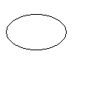

3) DATA STORE:

A data store stores data. Two parallel lines with square depict a data store. Process may store or retrieve data from a data store. It indicates operation of writing in the store. If it points away from the store, it indicates operation of reading form the stores. If both arrows are there, it indicates that one may write in or read form the store.
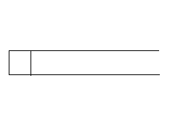
4) EXTERNAL ENTITY:

External entities are represented by the rectangle, and are outside the system, such as vendors or customers with whom the system interacts. The designers have no control over them. They either supply or consume data. Entities supplying data are known as sources and those that consume data are called sinks.

5) Relationship:

A relationship is an association between two or more entities that
is particular interest between database.

Entity Relationship Diagram

- 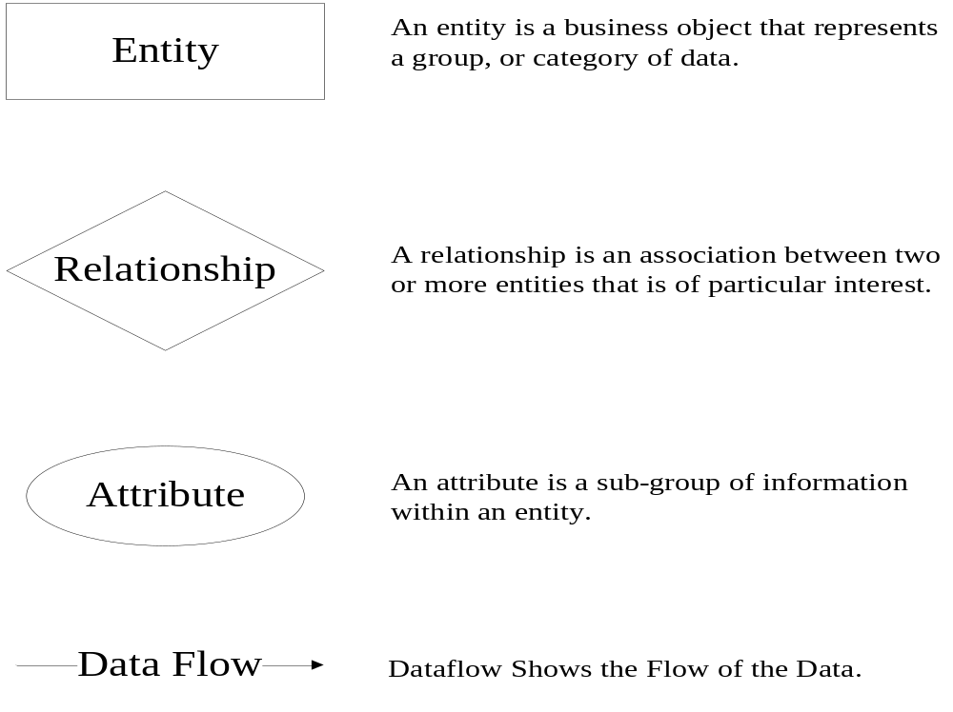Symbols:-

Parallel Line It symbolize Many –To Many Relationship

- File Naming Conventions
- File names should use proper letters only.
- File name should be same as that of the class in that file.
- File name should have first letter capital in every consecutive word.
- All code and text files should be completely free from TAB character.
- Control Conventions
The names used in project are as follows. :

Control Name | Prefix used in control name
LABEL | Lbl
TEXTBOX | Txt
BUTTON | Btn
DATALIST | Data
DATAGRID | Datagrid1
DROPDOWNLIST | Ddl
WATERMARKTEXTBOX(AJAXCONTROL) | Watermark
IMAGE CONTROL | Img
FILE UPLOAD | File
LINK BUTTON | Link
INTRODRUCTION


In today’s generation we haw working wary fast so these website is provide the facility of downloading and watching wallpaper essay.
We are a growing, profitable, technically advanced, well-managed for downloading Wallpapers. We offer an extremely practical and highly beneficial technology. We have the answer.

We have deliberately chosen to provide the most effective and responsive service organization. And we deliberately position our company as the most willing and the most able to take total responsibility for the success of your bar code investment.

We have still a limited knowledge and understanding of the wide number of technologies used by ordering list, so we hope that it is mostly accurate, complete and that it will help you.

The Purpose of this website is faster response to queries. Therefore it can replace or cancel order with a different date and time which will generate the same result set efficiently in less time. The new ordering list is faster because it will do less work when extracting the result tulles form the database

Technology Literature:
....A good website is much more than a few lines of code....

WHAT IS A-website?
A traditional answer would be something like: “Website development is the process where we get some requirements and we translate them into software”, right? Well, our experience in developing website’s, tells us that this is far from reality. Let’s see why:

- Customer only have a vision and few ideas, they don’t know about requirements
- Customers seldom understand technical limitations
- It is impossible to get all the requirements upfront
- Requirements are linked with each other by a very complex, very difficult to predict net of dependencies.

PROJECT PROFILE

Overview:
My Directory Pages is operate the any source and any businesses data to use.
When a particular user will go into the system, the view that will be displayed to the user will same as other. E.g. home page with search bar and category pages with categories and other pages that user have rights to access.

FEASIBILITY STUDY
Measure of how beneficial or practical the development of an information system will be to an organization.

TYPES OF FEASIBILITY STUDY :
  - Technical Feasibility
  - Economic Feasibility
  - Operational Feasibility
  - Schedule Feasibility
Technical Feasibility:
Technical feasibility is normally under take to find out whether the work can be done with the present equipment, current production, existing software technology and available personnel.
Economical Feasibility:
Economic feasibility analysis normally determines the cost and expected saving of each alternative that may be have decided.
Operational Feasibility:
Will the system be used if it is developed and implemented?
Will there be resistance from users?
Schedule Feasibility:
How reasonable is the project timetable?

Roles and Responsibilities
Roles and Responsibilities:
Task (Activity) | Manthankumar Satani
Understanding scope and objective | 
Project Planning | 
Requirement Collection and Analysis | 
Feasibility Study | 
Use Case Diagram | 
Class Diagram | 
Sequence Diagram, Activity Diagram | 
Data Dictionary | 
Normalization | 
Template Design | 
Design & Coding | 
Testing | 

Software & Hardware Requirements

Software Requirements
Serial No. | Name
1 | Visual Studio .Net 2010
3 | IIS 6.0
4 | SQL Server 2008 R2
5 | Visual Studio service pack – 1

System Design:-

Design Document:

- DFD

A Data Flow Diagram (DFD) is a graphical representation of the "Flow" of data through an information system. DFDs can also be used for the visualization of data processing (structured design).

On a DFD, data items flow from an external data source or an internal data store to an internal data store or an external data sink, via an internal process.

A DFD provides no information about the timing or ordering of processes, or about whether processes will operate in sequence or in parallel. It is therefore quite different from a flowchart, which shows the flow of control through an algorithm, allowing a reader to determine what operations will be performed, in what order, and under what circumstances, but not what kinds of data will be input to and output from the system, nor where the data will come from and go to, nor where the data will be stored (all of which are shown on a DFD).

Data Flow Diagrams (DFDs) are one of the three essential perspectives of the Structured-Systems Analysis and Design Method (SSADM). The sponsor of a project and the end users will need to be briefed and consulted throughout all stages of a system's evolution. With a data-flow diagram, users are able to visualize how the system will operate, what the system will accomplish, and how the system will be implemented.

The old system's dataflow diagrams can be drawn up and compared with the new system's Data Flow Diagrams to draw comparisons to implement a more efficient system. Data Flow Diagrams can be used to provide the end user with a physical idea of where the data they input ultimately has an effect upon the structure of the whole system from order to dispatch to report. How any system is developed can be determined through a Data Flow Diagram.

- System Design Tools

- E.R. Diagram:
Entity Relationship Model (ERM) is a technique used to analyze and model the data in organizations using an Entity Relationship (ER) Diagram.
In Software Engineering, an Entity-Relationship Model (ERM) is an abstract and conceptual representation of data. Entity-Relationship Modeling is a database modeling method, used to produce a type of conceptual schema or semantic data model of a system, often a relational database, and its requirements in a top-down fashion. Diagrams created by this process are called Entity-Relationship Diagrams, ER Diagrams, or ERDs

ER-Diagram
category

ID
businessname
website
facebook
fname
linkedin

admins
lname
twitter

email

businesses
pinterest
phone
description

fax
picurl
street
city
datetimes
country
zip
stat

stat

name
descr

ID
email
datetimes
usernm

categories

ID
pwd
usernm
datetimes
ID

contacts

- Data Dictionary

administrator
Column Name | Data Type | Description | Constraint
ID | int | It shows numbers | Identity  Not Null
Usernm | varchar(max) | It shows Admin Name | Not Null
Pwd | varchar(16) | It shows Password | Not Null

businesses
Column Name | Data Type | Description | Constraint
id | Int | It stores id | Primary key
fname | varchar(15) | It stores First name | Not Null
lname | varchar(15) | It stores Last name | Not Null
email | Varchaar(max) | It stores email address | Not null
Pwd | Varchar(16) | It stores password | Not null

wallinfo
Column Name | Data Type | Description | Constraint
id | int | It stores id | Primary key
thumbwallnm | varchar(max) | It stores thumbnail details | Not Null
Oriwallnm | varchar(max) | It stores original details | Not Null
Added_date | varchar(max) | It stores date | Not Null
Abstrac | Int | It stores 0 / 1 | Not Null
Animal | Int | It stores 0 / 1 | Not Null
Animation | Int | It stores 0 / 1 | Not Null
Boy | Int | It stores 0 / 1 | Not Null
Car | Int | It stores 0 / 1 | Not Null
City | Int | It stores 0 / 1 | Not Null
Flower | Int | It stores 0 / 1 | Not Null
Girl | Int | It stores 0 / 1 | Not null
Logo | Int | It sores 0 / 1 | Not null
Nature | Int | It stores 0 / 1 | Not null
Quotes | Int | It stores 0 / 1 | Not null

System Testing:
Testing Principle:
- Models of Testing:
- There are different Models of testing. On the basis of testing methods there are two types of testing:
  - White-box testing
  - Black-box testing
Black-box tests are used to demonstrate that software functions are operational, that input is properly accepted and output is correctly produced, and that integrity of external information is maintained.
White-box tests are used to examine the procedural details. It checks the logical paths by test case. It can also checks the conditions, loops used in the software coding. It checks that loops are working correctly on defined boundary value.
White-box testing:
  - White-box testing sometimes called glass-box testing, is a test case design method that users the control structure of the procedural design to drive the test case.
  - Always we are thinking that there is no necessary to execute or checks the loops and conditions and so large number of errors is uncovered.

With using white-box testing methods, we have checked that:
  - All independent paths within a function have been executed at least once.
  - All logical decisions are on their true and false side.
  - All loops working correctly at their boundary values and within their specified conditions.

In our coding we test that all the loops works truly in each module. The one technique of white-box testing is basis path testing. It contains two parts, one is flow graph notation and the second is cyclometer complexity. In flow graph notation we are checking logical control of flow. By using cyclometer complexity we find complexity of our project structure.
Black-box testing:
  - Black-box testing focuses on the functional requirements of the software. That is black-box testing enables the software engineer to drive sets of input conditions that will fully exercise all functional.
  - Requirements for the program, Black-box testing is not an alternative to white-box testing techniques. Rather, it is a complementary approach that is likely to uncover a different class of errors than white-box methods.

We use in our coding to find errors in the following categories:
  - Incorrect or missing functions
  - Interface errors
  - Errors in database
  - Performance errors
  - Initialization and termination errors
Sr.no | Procedure | Expected Results |  | Actual  Results
 | Check 'Inquiry' Page
1 | Check all the require field for creating Question. | If any required field is blank then error message should appear. | As Expected
2 | Check all function should work correctly of FCK editor. | FCK Editor must allow Uploading Image, YouTube videos, Flash files etc. All other functions of editor must work properly. | As Expected
3 | Check that correct Option is selected or not. | If Correct Option is not selected user must be acknowledged to select correct option. | As Expected
4 | Check that all dropdown of the inquiry is working Properly or not. | The must be Previewed properly. | As Expected
5 | Check Clear button is functioning properly or not. | All the fields of the page must be cleared. | As Expected
6 | Check Next button is working properly or not. | The Inquiry must be added and the entire field must be cleared to enter another question. | As Expected
7 | Selecting grade wise difficulties from Multiple combo boxes. | Grade selected in one combo box must not appear in other combo boxes. | As Expected
  - Unlike white-box testing, which is performed earlier in the testing process, black-box testing tends to be applied during later stages of testing. Because black-box testing purposely disregards control structure, attention is focused on the information domain.
By applying black-box techniques, we derive a set of test cases that satisfy following criteria
  - Test cases that reduce, by a count that is greater than one, the number of additional test cases must be designed to achieve reasonable testing.

Test Cases:

Sr.no | Procedure | Expected Results | Actual Results
 | Check 'Registration Test' Page
1 | Check all the require field for Registration. | Subscriber must enter values in all the required fields for generating Registration if any value is blank then error message should appear. | As Expected
2 | Check before registration particular  Registration fees is paid or no | particular Registration fees is paid or no | As Expected
3 | Grand Total Of Amount Of Selected Course And Among them  Selected Module | In customized test when user Selects Course and module each category total must be automatically done and result should be displayed in the textbox and it must be read only. | As Expected
4 | Confirm registration(insert in to database) | After all the process for conformation click on save to all things save to database | As Expected
5 | Delete And Replace Registration  Detail | When user deletes some Detail from the test they should be replaced by some other detail falling in same criteria. | As Expected
6 | Save Detail | When user saves test it should be saved in the database and can be used later | As Expected

Reno | Procedure | Expected Results | Actual Results
 | Check follow up master
1 | Display all the follow-up for taking for the student | When user selects subject all unapproved questions of that subject must be listed. | As Expected
2 | Add Comment & view comments. | Approver must be able to add comments on the follow-up of the student as well as must be able to view comments given by others. | As Expected
3 | Give another follow-ups if it is in right way | If counselor think this person may join the course we need a some action to join them then they take another follow-up | As Expected
4 | Update Follow-ups | When questions approver clicks on update question approver must be able to update the details of that question. | As Expected
5 | Delete Follow up | When counselor deletes the follow up it should be deleted from database. | As Expected

- Test Strategy:
  - During the analysis phase, you gather and validate the business requirements for the solution. It makes sense that the Testing Strategy is completed during this phase as well. In a sense, you are defining the overall testing requirements.

  - The purpose of the Testing Strategy is to define the overall context for the entire testing process. The process is different depending on the specific characteristics of your solution. In many respects, this is the most important part of the testing process, since all future
  - Testing decisions will be made within the context of the strategy. Here are the basic parts of the testing strategy:
Business Risks:
  - These are high-level risks of the project that will affect the overall testing strategy. For instance, the risk of doing business on the Internet may drive the need for rigorous system tests of firewalls, technical architecture, and security. The risks can be classified as high, medium, and low, depending on the nature and impact of the problem. For each high and medium risk, identify what elements in the overall testing approach will help ensure that the potential problem does not occur.

Testing Milestones:
  - This section gives the reader a preliminary overview of the testing timelines. Obviously, since this document is created in the analysis phase, these dates are subject to later revision.
Testing Approach:
  - This describes the testing process at a high level, including how you will conduct unit testing, integration testing, system testing, and acceptance testing. (If your project is large enough, each of these might be its own section.) This is where you make fundamental decisions regarding the type of testing that makes sense for your project.
  - For instance, if you are implementing a packaged solution, the approach may start in system testing, with the vendor providing close support. If you are doing iterative development cycles, the testing approach will reflect this overall development life cycle. For system testing, define the major testing events, such as stress testing, security testing, disaster recovery testing, usability testing, and response time testing.
Testing Environment:
Think through the technologies and facilities needed for the testing process. If the overall testing environment needs are understood up front, it will be easier to break out the specific activities required to put the environment in place. In addition, you may need to plan for and acquire some parts of the environment well in advance.

- Testing Methods:
Unit Testing:
    - Unit testing is a procedure used to validate that individual modules or units of source code is working properly. It is a test for a specific unit. The primary goal of unit testing is to take the smallest piece of testable software in the application, isolate it from the remainder of the code, and determine whether it behaves exactly as you expect. Each unit is tested separately before integrating them into modules to test the interfaces between modules. A large percentage of defects are identified during this testing. Unit testing is typically done by the developers and not by end-users.

Integration Testing:
    - Integration testing is a logical extension of unit testing. In its simplest form, two units that have already been tested are combined into a component and the interface between them is tested. A component, in this sense, refers to an integrated aggregate of more than one unit. Integration testing identifies problems that occur when units are combined. This method reduces the number of possibilities to a far simpler level of analysis. Integration testing follows unit testing and precedes system testing.

System Testing:
    - System testing is testing conducted on a complete, integrated system to evaluate the system's compliance with its specified requirements. As a rule, system testing takes, as its input, all of the "integrated" software components that have successfully passed integration testing and also the software system itself integrated with any applicable hardware system(s). The software is integrated to the overall product and tested to show that all requirements are met

- Screen Shots

- Admin Side:-

- Admin Login:

This web form is just only for the admin. It is the first page of admin side. Admin can logged in by this form.

- Admin Update:

It shows when the admin will login. It is the next page after login. It known as Update page. It is use to add new wallpapers in database.

- Admin Table:

It is use to watch how many use are registered and how many wallpapers are available on site and it shows wallpaper’s categories.

- User Side:-

- Home page:

It is the first page when the user visits the site.

- Log in:

This web page is use to make user logged in.

- Register:

This web page is use to sign up to user on website.

- Abstract:

This web page comes when user select the Abstract from categories tab.

- Animals & Birds:

This web page comes when user select the Animals & Birds from categories tab.

- Animation & Movies :

This web page comes when user select the Animation & Movies from categories tab.

- Boys :

This web page comes when user select the Boys from categories tab.

- Cars & Bikes :

This web page comes when user select the Cars & Bikes from categories tab.

- City :

This web page comes when user select the City from categories tab.

- Flowers & Foods :

This web page comes when user select the Flowers & Foods from categories tab.

- Girls :

This web page comes when user select the Girls from categories tab.

.

- Logos :

This web page comes when user select the Logos from categories tab.

- Nature :

This web page comes when user select the Nature from categories tab.

- Quotes :

This web page comes when user select the Quotes from categories tab.

- Enhancement of Project

A s web application is well established here we have try to narrate some point that are really considered as required enhancement in this system.

Implementing more routs and more facility for users.

Implementing message board where each member can share their ideas.

Implementing online help like customer care to through the chat where member can get more ideas.

- Limitation of Project

The first limitation is user can select only one sit at a time.

Right now the website does not support all browsers because of the different plugging for different browsers.

Right now the website does not support all browsers because of the different plugging for different browsers that’s way the website is also give different output on different resolution.

- Conclusion

WallPaper is a useful website for all kind of peoples for Wallpaper download for their entertainment.

It will bring new dimensions on downloading wallpaper.

It’s very easy to watching a wallpaper through our website.

It also gives information about facility which is given by our website.

- Bibliography

Web Site

- www.w3schools.com

